**1. Introduction**

**Project Report: Exam Handling Management System using ASP.NET**

## 1. Introduction

**Project Overview**

**The project involves developing an Exam Handling Management System to streamline the process of creating, managing, and grading exams using ASP.NET. The system ensures secure and efficient exam handling for educational institutions.**

**Purpose and Scope**

**The purpose of this project is to automate the exam process, from creation to grading, while maintaining security and integrity. The scope includes user management, exam creation, distribution, grading, and result analysis.**

**Key Features**

* **Secure Exam Creation and Management**
* **User Authentication and Roles**
* **Automated Grading System**
* **Detailed Result Analysis and Reporting**

## 2. System Design and Architecture

**Overview of the System Architecture**

The system is designed using a client-server architecture. The front end provides an intuitive interface for administrators, teachers, and students, while the backend manages data processing and storage.

**Database Schema and Data Flow**

The database is structured using SQL Server to store user information, exam data, and results. Data flows securely between the client and server through encrypted channels to ensure data integrity and privacy.

**User Interface Design**

The user interface is designed to be user-friendly . It includes features for creating and managing exams, submitting responses, and viewing results**.**

## 3. Development Process

**Technology Stack**

* **Frontend: HTML, CSS, JavaScript**
* **Backend: ASP.NET Core**
* **Database: SQL Server**

**Development Workflow**

**The development process followed an agile methodology, with iterative sprints and regular feedback sessions to ensure continuous improvement and adaptability.**

**Challenges and Solutions**

* **Challenge: Ensuring secure authentication and data transmission.**
  + **Solution: Implemented ASP.NET Identity for secure user authentication and used HTTPS for encrypted data transmission.**

## 4. Features and Functionalities

**Exam Creation and Management**

The system allows administrators and teachers to create and manage exams, including setting questions, assigning grades, and scheduling exams**.**

**User Authentication and Roles**

The system includes secure login functionality with role-based access control, ensuring that only authorized users can access sensitive data and features.

**Detailed Result Analysis and Reporting**

The system generates detailed reports on student performance, including individual and overall exam analysis, helping educators make data-driven decisions.

## 5. Testing and Quality Assurance

**Testing Methodologies**

The system underwent rigorous testing using both manual and automated techniques to ensure functionality, security, and performance.

**Test Cases and Results**

* **User Authentication:** Passed all test cases, ensuring secure and reliable login.
* **Exam Management:** Verified the functionality of exam creation, distribution, and grading.

**Bug Fixes and Enhancements**

Regular bug tracking and resolution were carried out throughout the development process, with enhancements made based on user feedback and testing results.

## User Interface Design

**The Exam Handling Management System is designed with user-friendliness in mind. When users first enter the system, they are greeted by a welcoming and intuitive landing page. This landing page serves as the central hub from which users can easily navigate to different sections of the system based on their roles (administrator, teacher, or student).**

**Landing Page**

**Upon entering the system, the first thing users see is the landing page, which is designed to be both visually appealing and functional. The landing page includes:**

* **Friendly Welcome Message: A warm and inviting message that sets the tone for the user's experience.**
* **Navigation Menu: A clear and easy-to-use navigation menu that allows users to access key features and sections with a single click.**
* **Quick Links: Direct access to important functions such as exam creation, user management, and result analysis.**

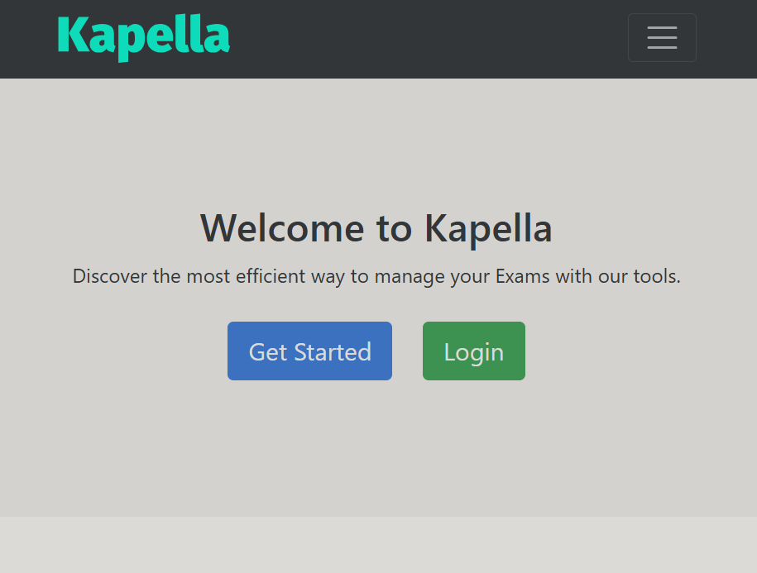

## Registration Process

**For new users, the registration process is designed to be smooth and user-friendly. When users opt to sign up, they are directed to a registration page that includes:**

* **Step-by-Step Guidance: The registration page guides users through the process step-by-step, ensuring they understand each stage.**
* **User Information Collection: Input fields for necessary information such as name, email address, password, and user role (administrator, teacher, or student).**
* **Validation Checks: Real-time validation checks to ensure that the information entered is correct and meets the required criteria (e.g., password strength, valid email format).**
* **Confirmation and Welcome: Upon successful registration, users receive a confirmation message and are redirected to the login page. A welcome email is also sent to their registered email address, providing them with important information and next steps.**

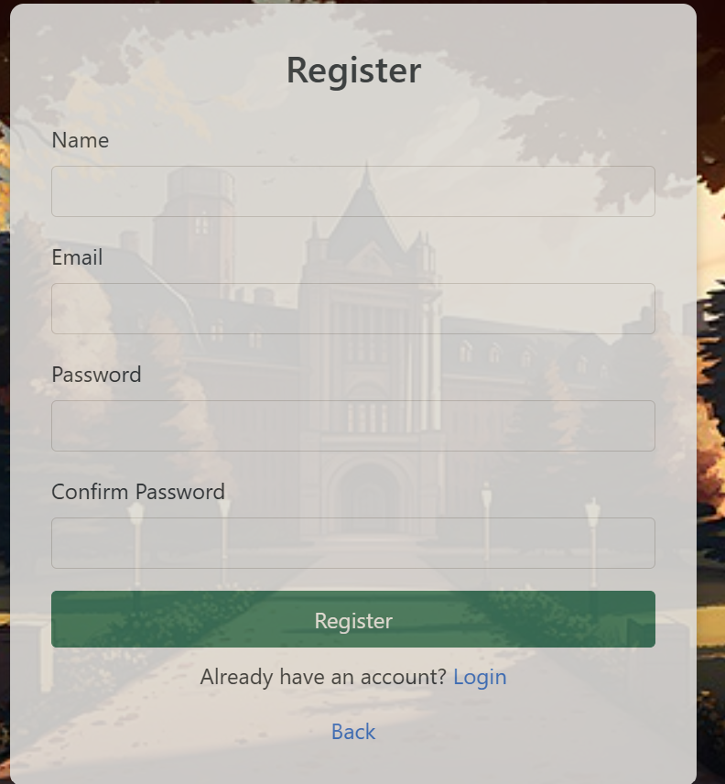

## Login and Signup Process

**When users click on the Login button, they are directed to a user-friendly login page designed to guide them through the process seamlessly. The login page includes:**

* **Clear Instructions: Simple and clear instructions are provided to help users understand the login or signup process.**
* **Input Fields: Easy-to-navigate input fields for entering usernames and passwords.**
* **Guided Assistance: Helpful hints and tooltips are available to assist users in case they encounter any difficulties during the login or signup process.**
* **Password Recovery: Options for password recovery are clearly visible, ensuring that users can easily retrieve their credentials if forgotten.**
* **Signup Option: New users are provided with an option to sign up, with a guided and straightforward process that collects necessary information securely.**

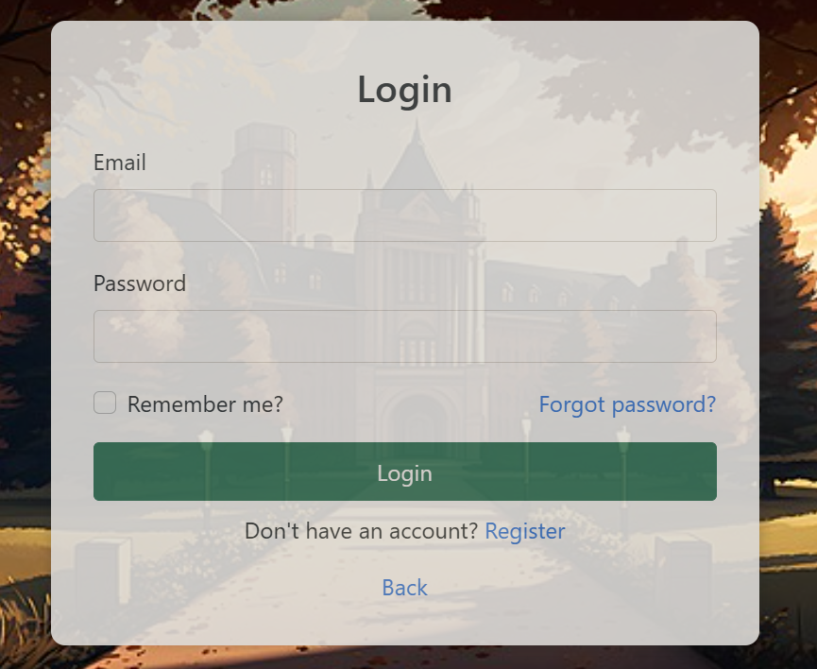

## Dashboard Overview

The dashboard serves as the central hub for users, providing easy access to various features and functionalities of the Exam Handling Management System. Designed with user-friendliness and efficiency in mind, the dashboard ensures that users can navigate the system effortlessly.

**Key Elements of the Dashboard**

1. **Navigation Bar:**
   * **Top Navigation Bar:** Located at the top of the dashboard, this bar includes several icons and menu options for quick access.
     + **Notifications Icon:** Displays the number of new notifications (e.g., "2").
     + **Messages Icon:** Shows the number of unread messages (e.g., "4").
     + **Search Bar:** Allows users to search for specific information within the system.
2. **Main Navigation Options:**
   * Centrally positioned on the dashboard, these options provide direct access to different sections:
     + **User:** Manages user accounts and profiles.
     + **Questions:** Creates and manages exam questions.
     + **Answers:** Handles the answers submitted by students.
     + **Results:** Manages and analyzes exam results.
     + **Exam:** Creates and schedules exams.
3. **Additional Menu Options:**
   * Located on the right side of the dashboard, these options offer further functionalities:
     + **Product:** Accesses product-related features.
     + **Reports:** Provides access to various reports with a dropdown menu for more options.
     + **Settings:** Allows users to configure system settings.
     + **User Profile:** Displays the logged-in user's name (e.g., "Anas") and profile picture.
4. **Sample Pages Section:**
   * On the far right, this section includes an icon that provides access to sample pages, offering users examples and templates to use within the system.

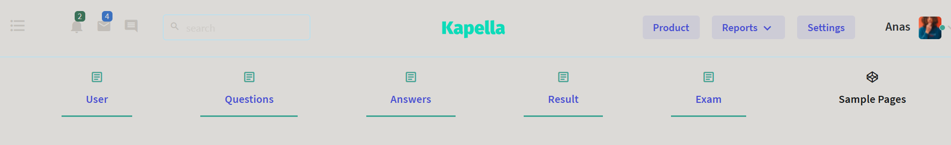

## User Management Interface:

The user management interface lists users with their usernames, email addresses, roles, and available actions. The table includes columns for "Username," "Email," "Role," and "Actions." Each row represents a user, and the "Actions" column provides buttons for:

* **Details:** Viewing more information about a specific user.
* **Edit:** Modifying the user's details such as username, email, and role.
* **Delete:** Removing a user from the system.
* **Create New User:** Adding a new user to the system.

**Functionality of the User Management Interface:**

1. **Viewing User Details:** The "Details" button allows viewing more information about a specific user, including their profile and activity within the system.
2. **Editing User Information:** The "Edit" button enables modifying the user's details, ensuring that administrators can keep user information up to date.
3. **Deleting Users:** The "Delete" button allows removing a user from the system, ensuring that only authorized users have access.
4. **Creating New Users:** The "Create New User" button facilitates adding a new user to the system, making it easy to expand the user base.

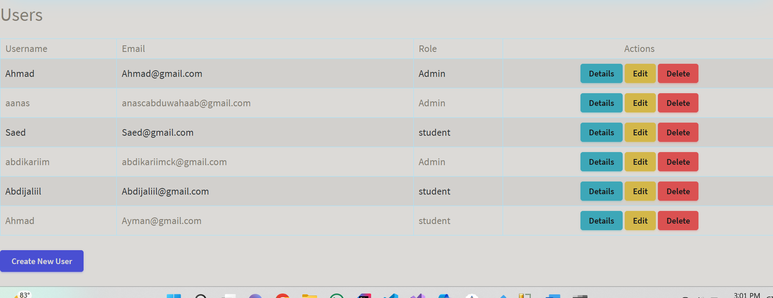

## Conclusion

The Exam Handling Management System project successfully delivered a comprehensive and secure platform to manage exams for educational institutions. By leveraging ASP.NET and a robust technology stack, the system provides a user-friendly interface, streamlined processes, and reliable functionality that meets the needs of administrators, teachers, and students.

Throughout the development process, we adhered to agile methodologies, ensuring continuous improvement and adaptability. The system's key features, including secure exam creation, user authentication, automated grading, and detailed result analysis, have been meticulously designed and implemented to enhance efficiency and accuracy.

The user-friendly dashboard and guided login, signup, and registration processes contribute to a seamless user experience, while the detailed reports and analytics offer valuable insights into student performance. The deployment and maintenance strategies ensure that the system remains stable, secure, and scalable.

In summary, the Exam Handling Management System achieves its primary objectives of automating the exam process, ensuring data integrity, and providing a solid foundation for future enhancements. The project reflects our commitment to delivering high-quality solutions that address the challenges faced by educational institutions in managing exams.

**Reflections and Learnings**

The development process offered valuable insights into secure coding practices, user-centered design, and agile methodologies. The team demonstrated resilience and collaboration in overcoming challenges, resulting in a robust and effective system.

## References

* **ThemeWagon. Kebella - Free Bootstrap 4 Admin Template. Retrieved from**
* **[https://themewagon.com/theme-category/landing-website/page/2/?swoof=1&really_curr_tax=17-product_cat]**